# **SCRUM Framework Summary**

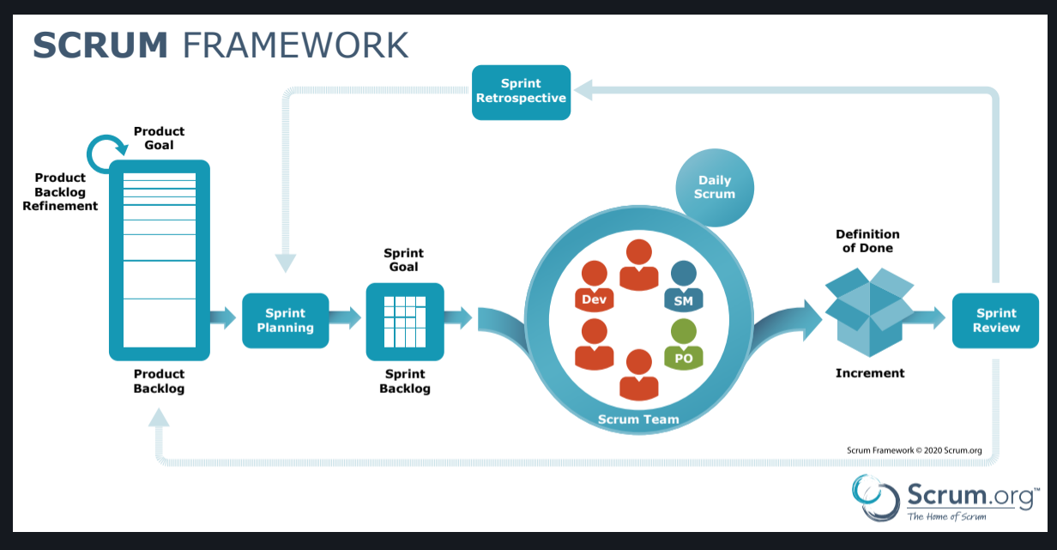

## **What is Scrum?**

Scrum is a **lightweight agile framework** for developing, delivering, and sustaining complex products.  
 It emphasizes **iterative progress**, **collaboration**, **accountability**, and **continuous improvement**.  
 Scrum is simple to understand but difficult to master.

## **Key Roles in Scrum**

| **Role** | **Responsibility** |
| --- | --- |
| **Product Owner** | Defines the product vision, manages the Product Backlog, prioritizes features based on business value. |
| **Scrum Master** | Facilitates Scrum processes, removes impediments, coaches the team on Scrum principles. |
| **Development Team** | Cross-functional group that builds the product increment in each Sprint. Responsible for delivering high-quality work. |

## **Scrum Artifacts**

| **Artifact** | **Purpose** |
| --- | --- |
| **Product Backlog** | An ordered list of everything that might be needed in the product. Continuously evolving. |
| **Sprint Backlog** | A list of selected Product Backlog items plus a plan for delivering them in the Sprint. |
| **Increment** | The sum of all completed Product Backlog items during a Sprint. A potentially shippable product. |

## **Scrum Events**

| **Event** | **Description** |
| --- | --- |
| **Sprint** | A time-boxed iteration (usually 2-4 weeks) where work is completed to deliver a usable product increment. |
| **Sprint Planning** | Meeting to decide what will be delivered in the upcoming Sprint and how the work will be done. |
| **Daily Scrum** | 15-minute daily stand-up where the team synchronizes activities and creates a plan for the next 24 hours. |
| **Sprint Review** | Meeting held at the end of the Sprint to inspect the Increment and adapt the Product Backlog if needed. |
| **Sprint Retrospective** | Meeting after the Sprint Review to reflect on the Sprint and define improvements for the next Sprint. |

## **Scrum Flow (Simple Steps)**

1. **Product Owner** refines and prioritizes Product Backlog.
2. **Sprint Planning** is conducted — team selects items to work on.
3. **Development Team** works during the Sprint, conducting **Daily Scrums**.
4. At the end, the **Sprint Review** demonstrates the Increment.
5. **Sprint Retrospective** identifies what can be improved.
6. **Cycle repeats** with next Sprint.

# **Key Principles of Scrum**

* **Transparency:** Everyone has visibility into the work and process.
* **Inspection:** Regularly check progress toward goals.
* **Adaptation:** Adjust process and backlog based on inspection results.
* **Empirical Process Control:** Decisions are made based on observations and experience, not theory.
* **Self-organization:** Teams decide how best to accomplish their work.
* **Continuous Improvement:** Always look for ways to improve team performance and product quality.

# **Why Use Scrum?**

* Embraces changing requirements, even late in the development process.
* Ensures frequent delivery of working software.
* Encourages customer feedback early and often.
* Increases collaboration, ownership, and team accountability.
* Promotes sustainable pace and long-term product quality.

✅ **Conclusion:** Scrum is a powerful way to manage and control complex product development with high transparency, collaboration, and continuous delivery — ensuring maximum value to the customer.